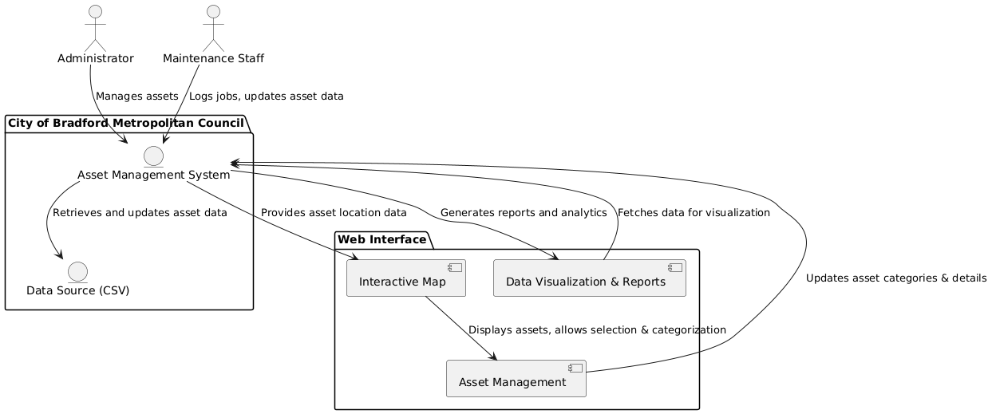

The provided UML case diagram appears to illustrate an enterprise system, most likely focusing on interaction among different entities such as users, systems, and external services. UML case diagrams assist in describing the functional needs of a system by indicating interactions between actors (users or external systems) and use cases (specific functionalities or actions).
Here, the primary actors may be Admin, Employee, and Customer, each of whom would interact with the system to perform some tasks. For example:
Admin might handle user accounts, system settings, and monitor processes.
Employee might handle tasks like order processing, inventory management, or report generation.
Customer might interact with the system to order products, track shipments, or look at product details.
The use cases presented likely include elements such as Login, Handle Orders, Prepare Reports, and Maintain Inventory. These use cases represent the essential actions that are carried out by the system. Linesbetween the actors and the use cases depict what can be performed by whom.
Also, the diagram can illustrate use case dependencies or use case extensions. For instance, Generate Reports might be a function of data from Manage Orders, or Update Inventory could be a result of Place Order.
Generally, the diagram illustrates a bird's-eye view of systemfunctionality, which encapsulates how users interact with the system to achieve some objective. The diagram is fundamentally a blueprint for comprehending the system requirements and designing the system architecture.

